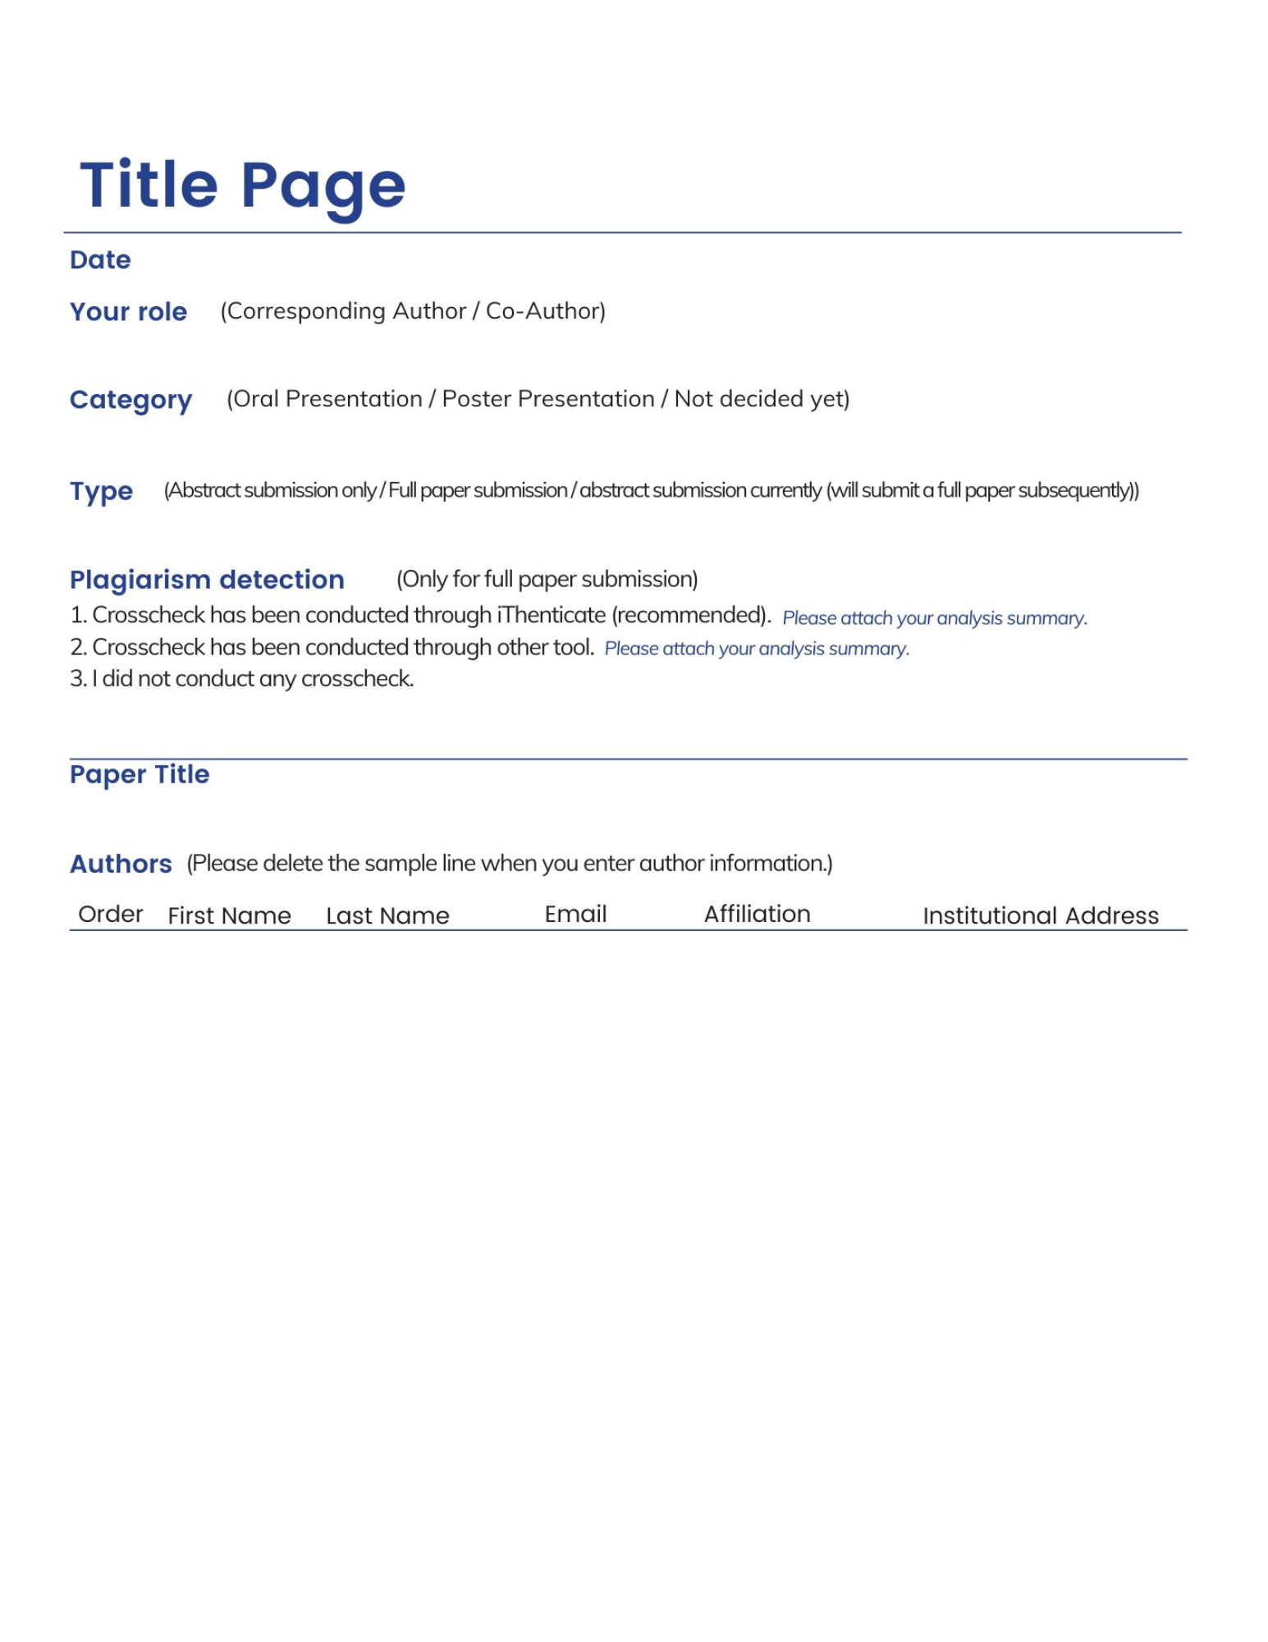

1
2
3
4
5

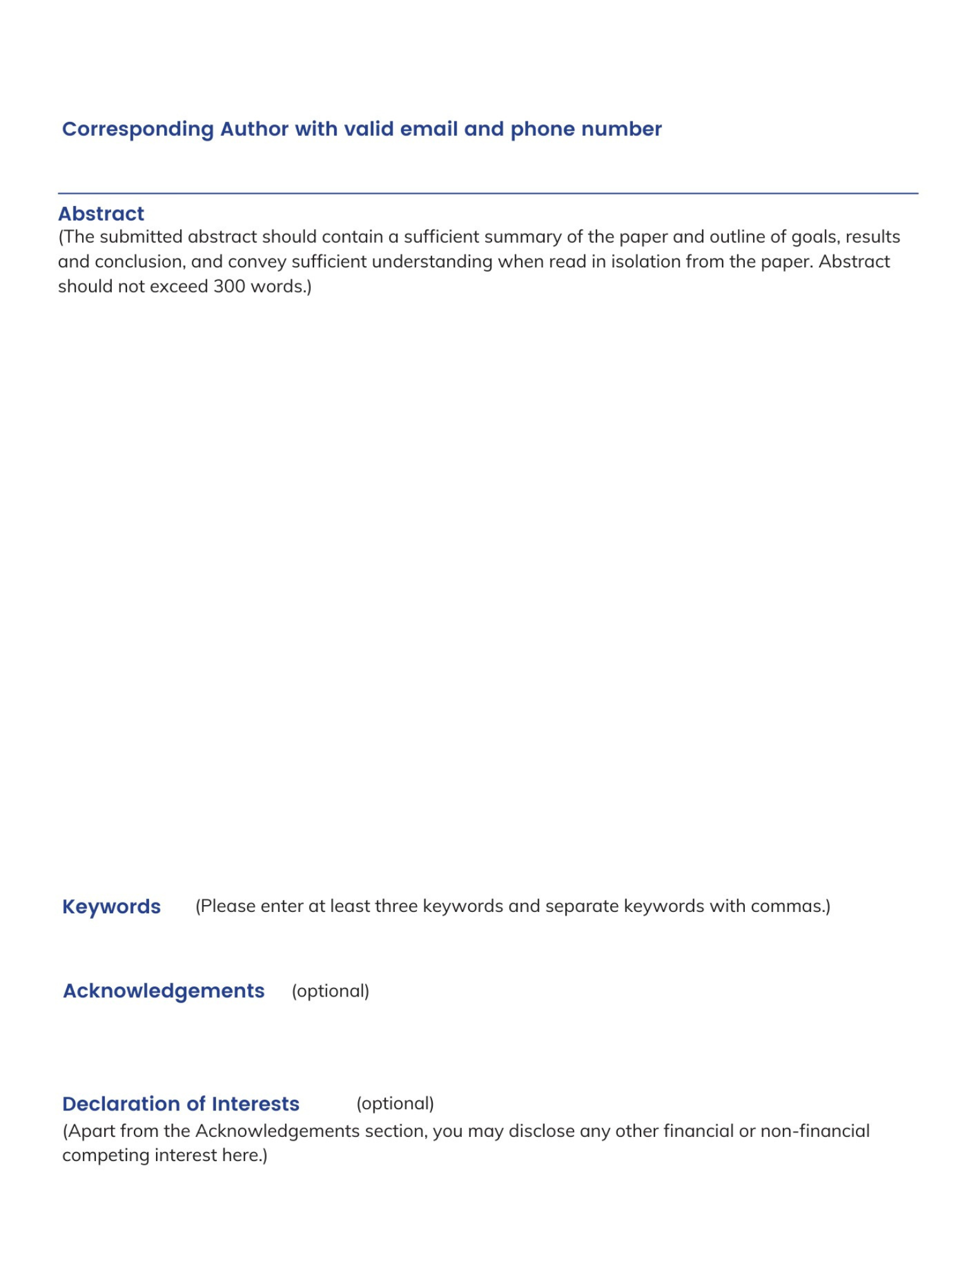

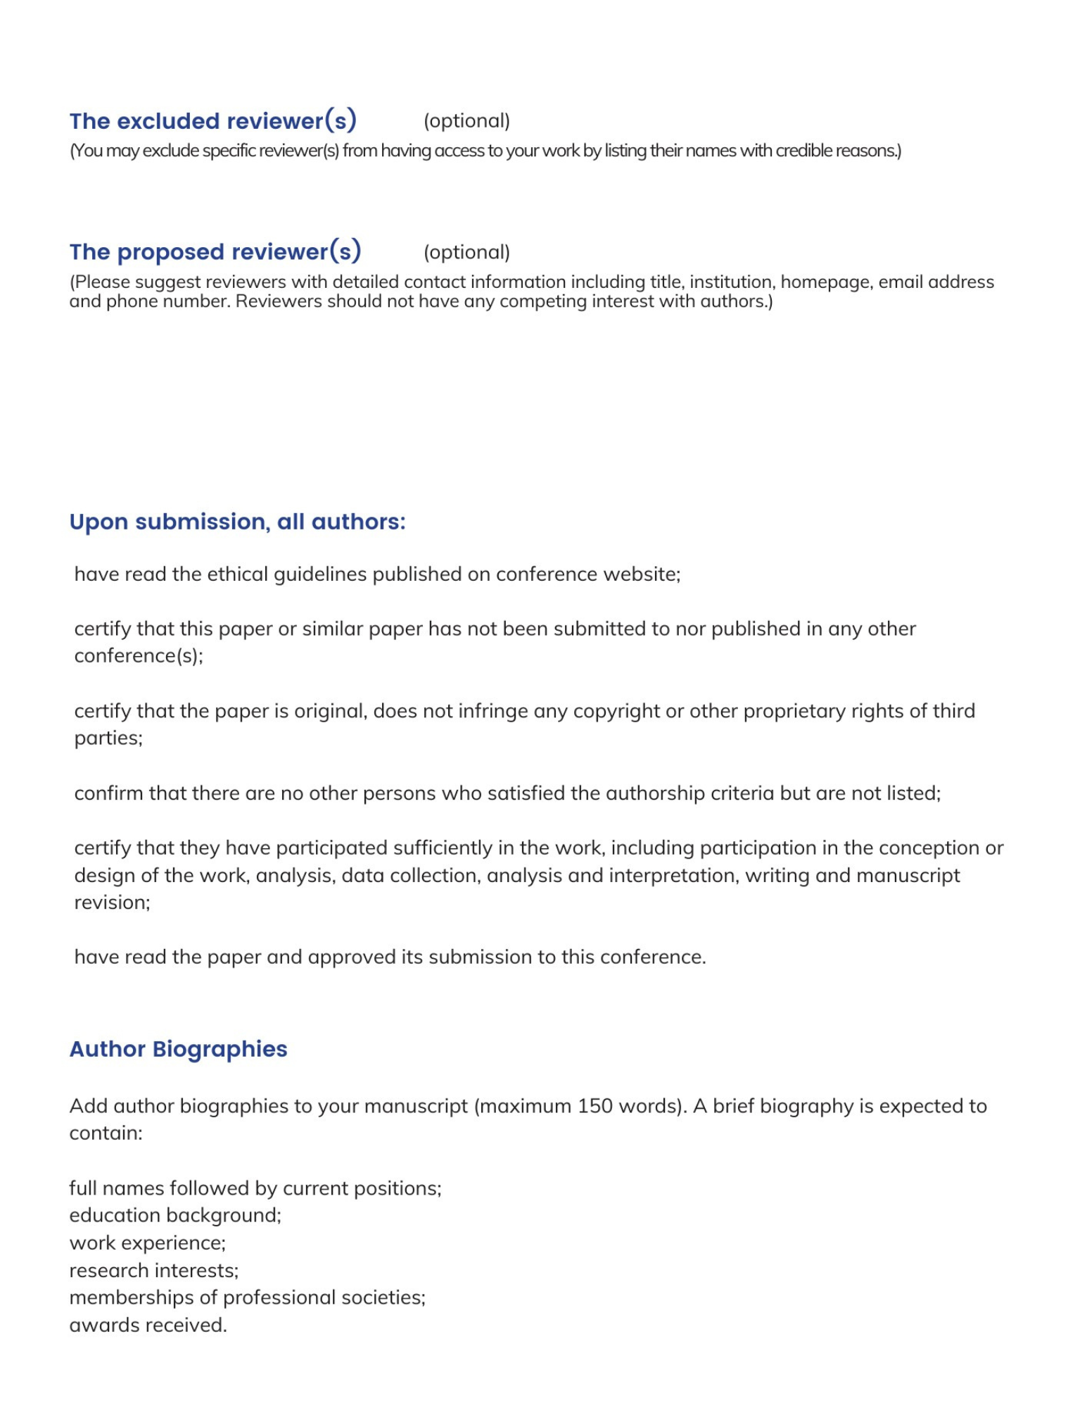



Email: inquiry@ichvr.org
Tel: 028-85027305 (Mainland)
+86-28-85027305 (International)
Monday-Friday, 9:30am-12:00pm and 1:30pm-6:00pm
Full Name | Short Biography (Maximum 150 words)

