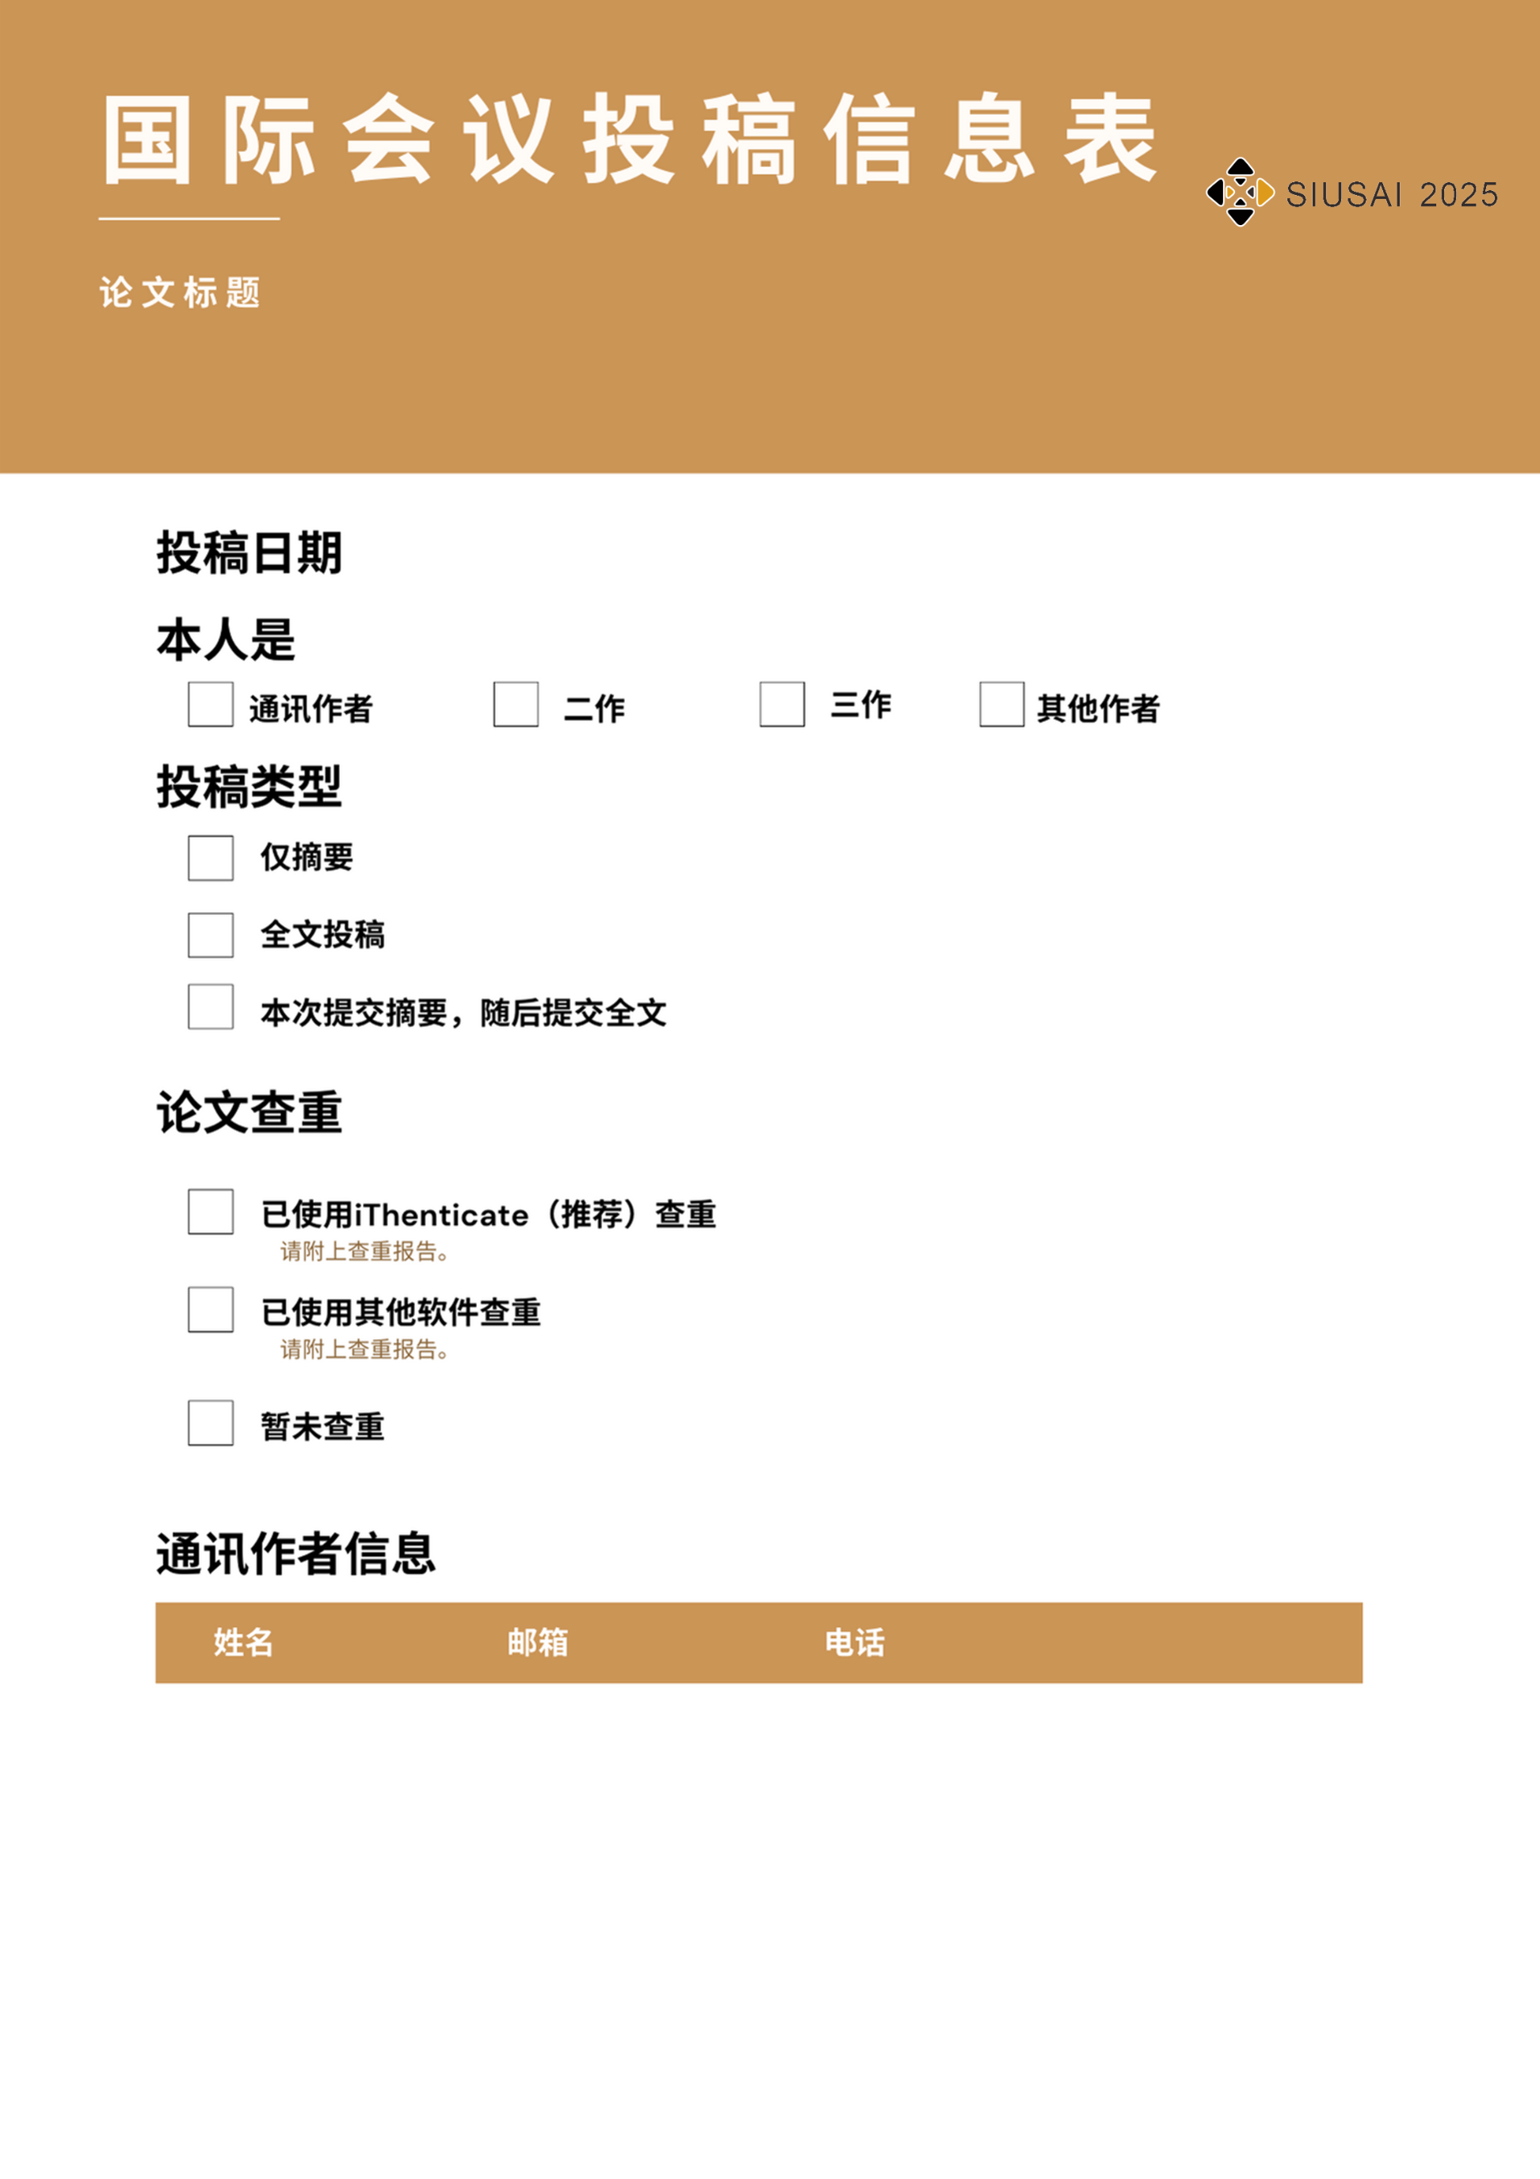

✓

✓

|  |  |  |
| --- | --- | --- |
|  |  |  |

✓

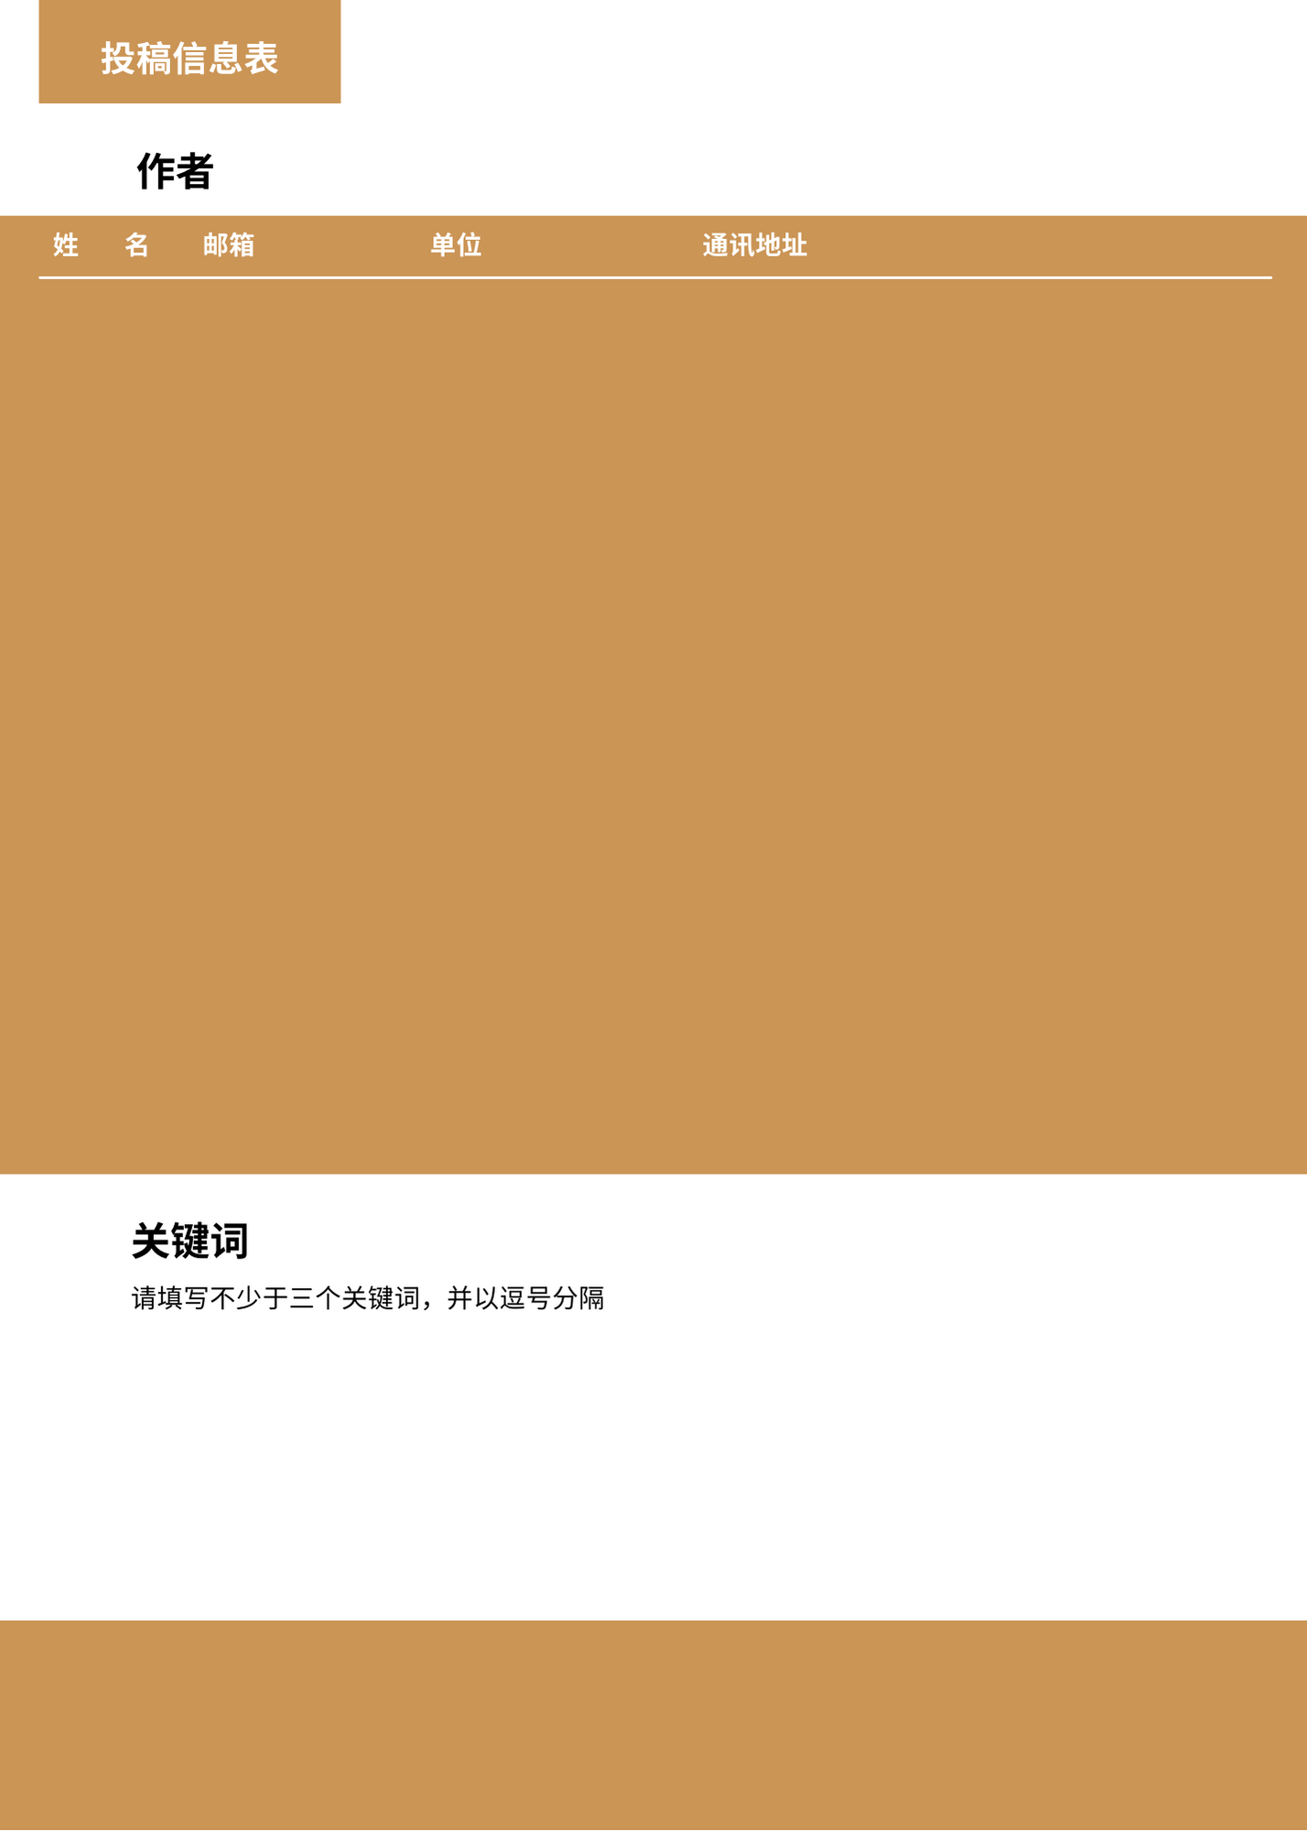



**2025年第四届智能无人系统与人工智能国际会议**

|  |  |  |  |  |
| --- | --- | --- | --- | --- |
|  |  |  |  |  |
|  |  |  |  |  |
|  |  |  |  |  |
|  |  |  |  |  |
|  |  |  |  |  |

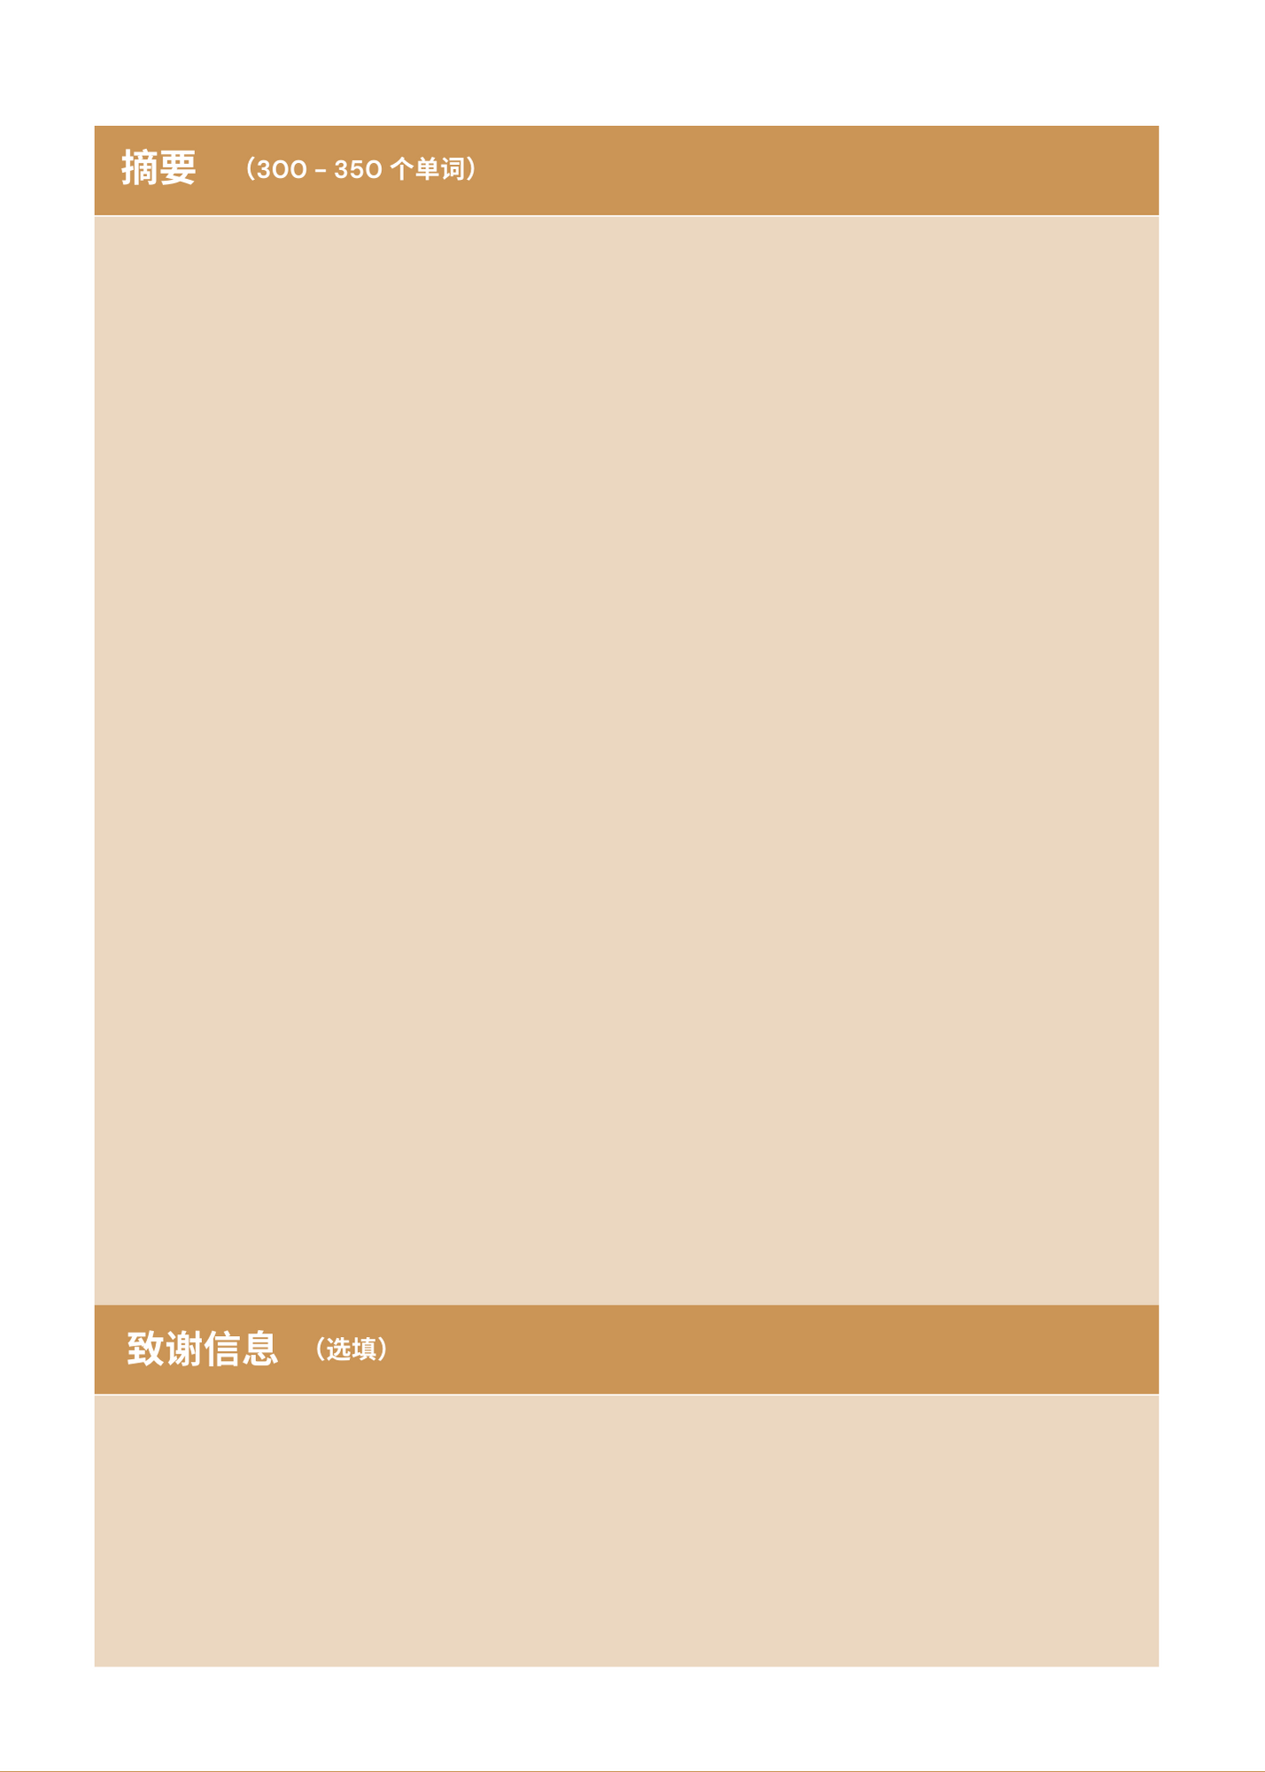

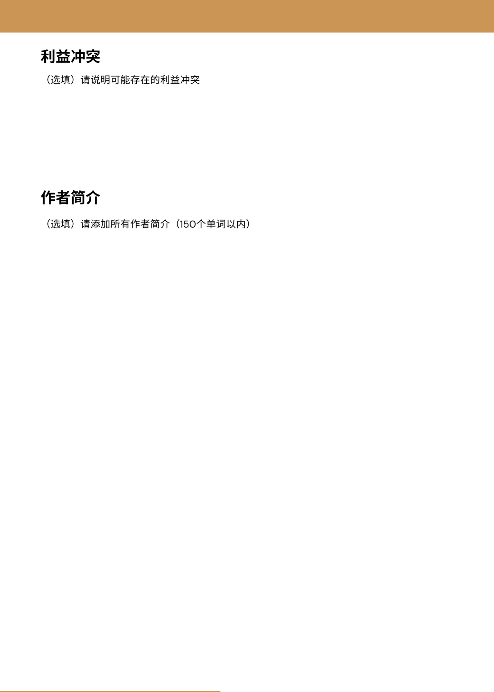

|  |  |
| --- | --- |
| **姓名** | **简介** |
|  |  |
|  |  |
|  |  |
|  |  |
|  |  |

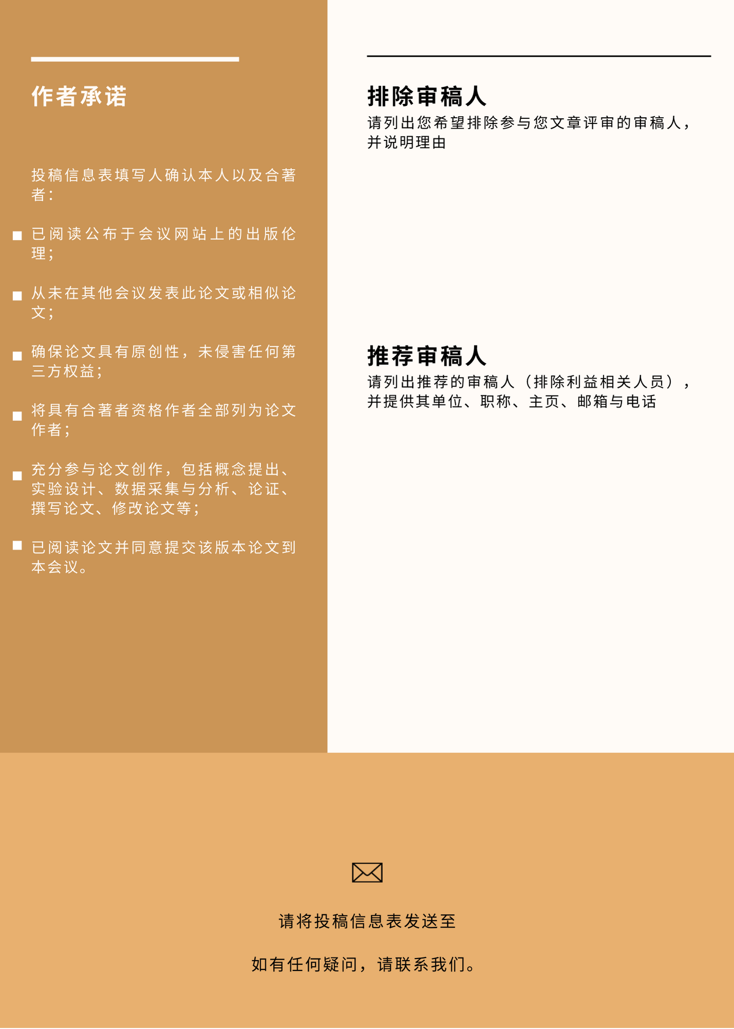

conf@siusai.org