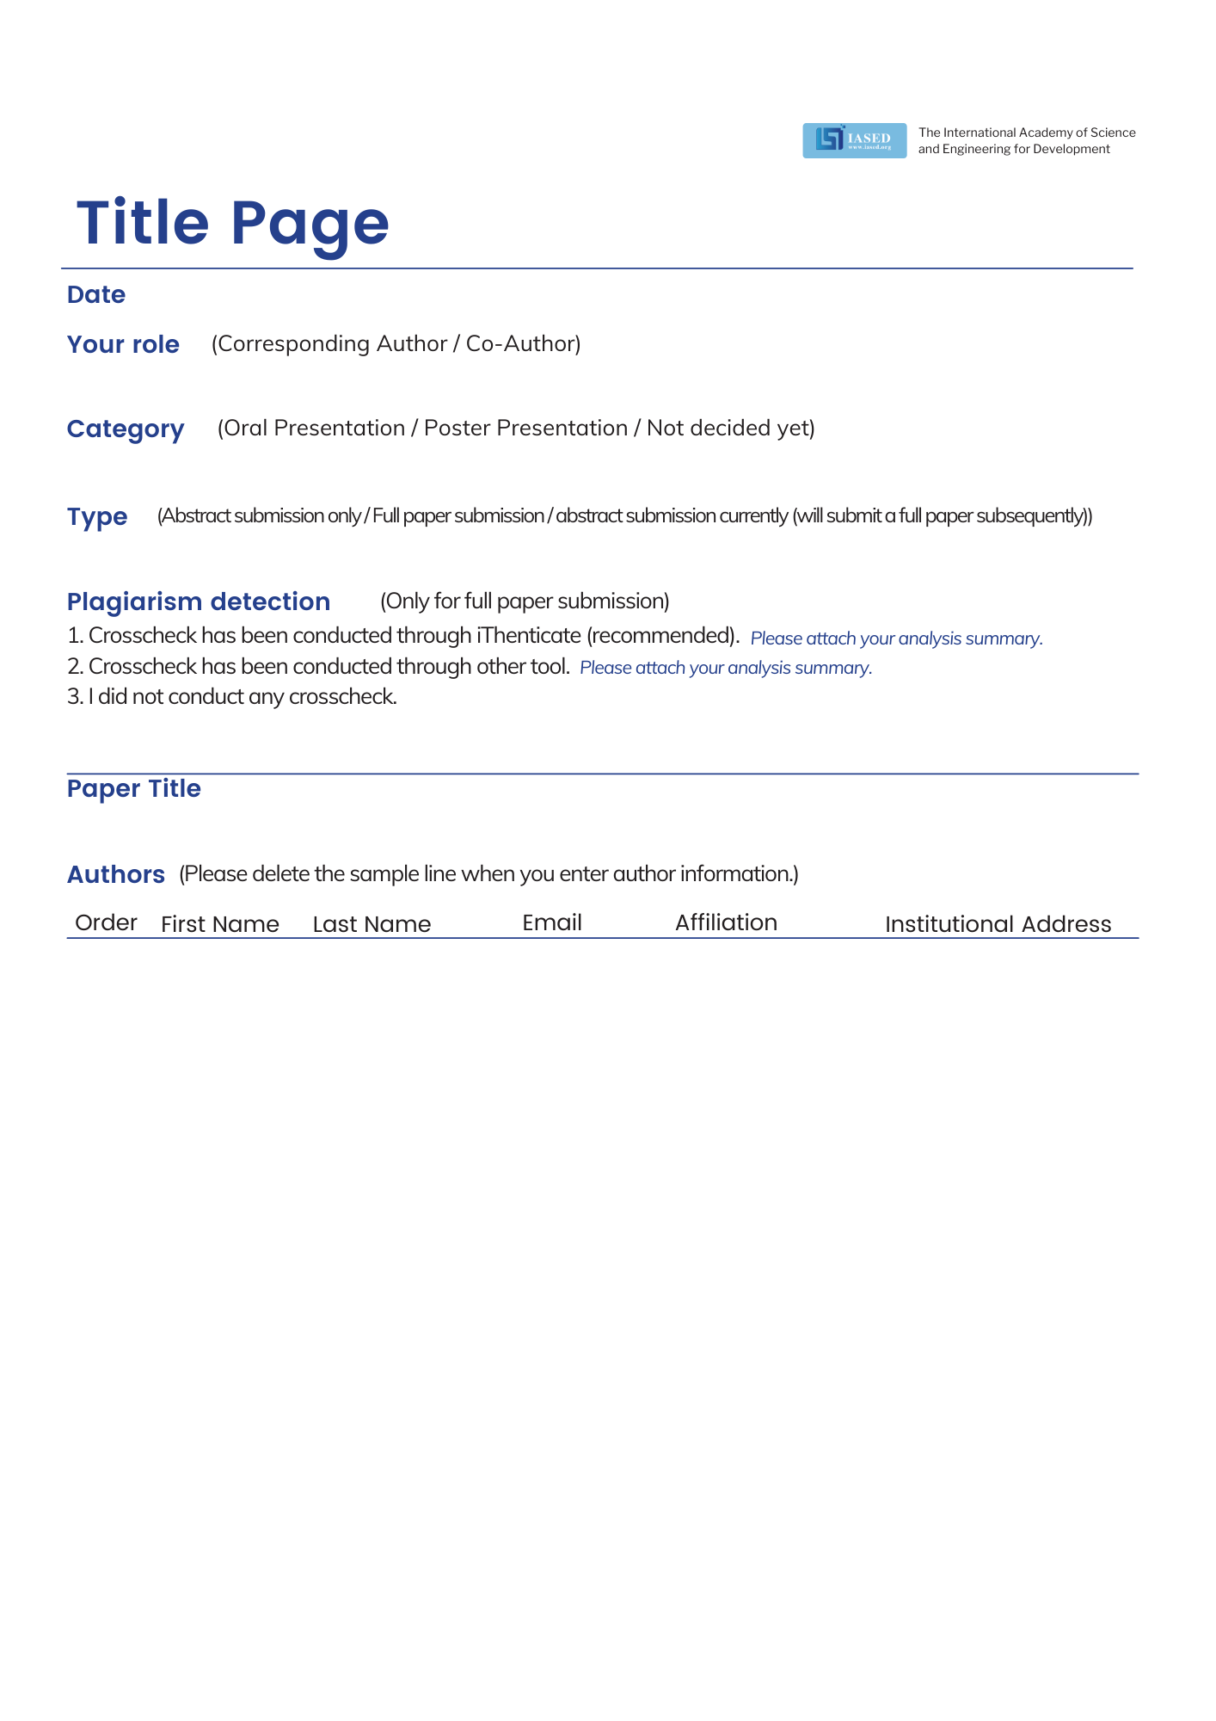

1
2
3
4
5

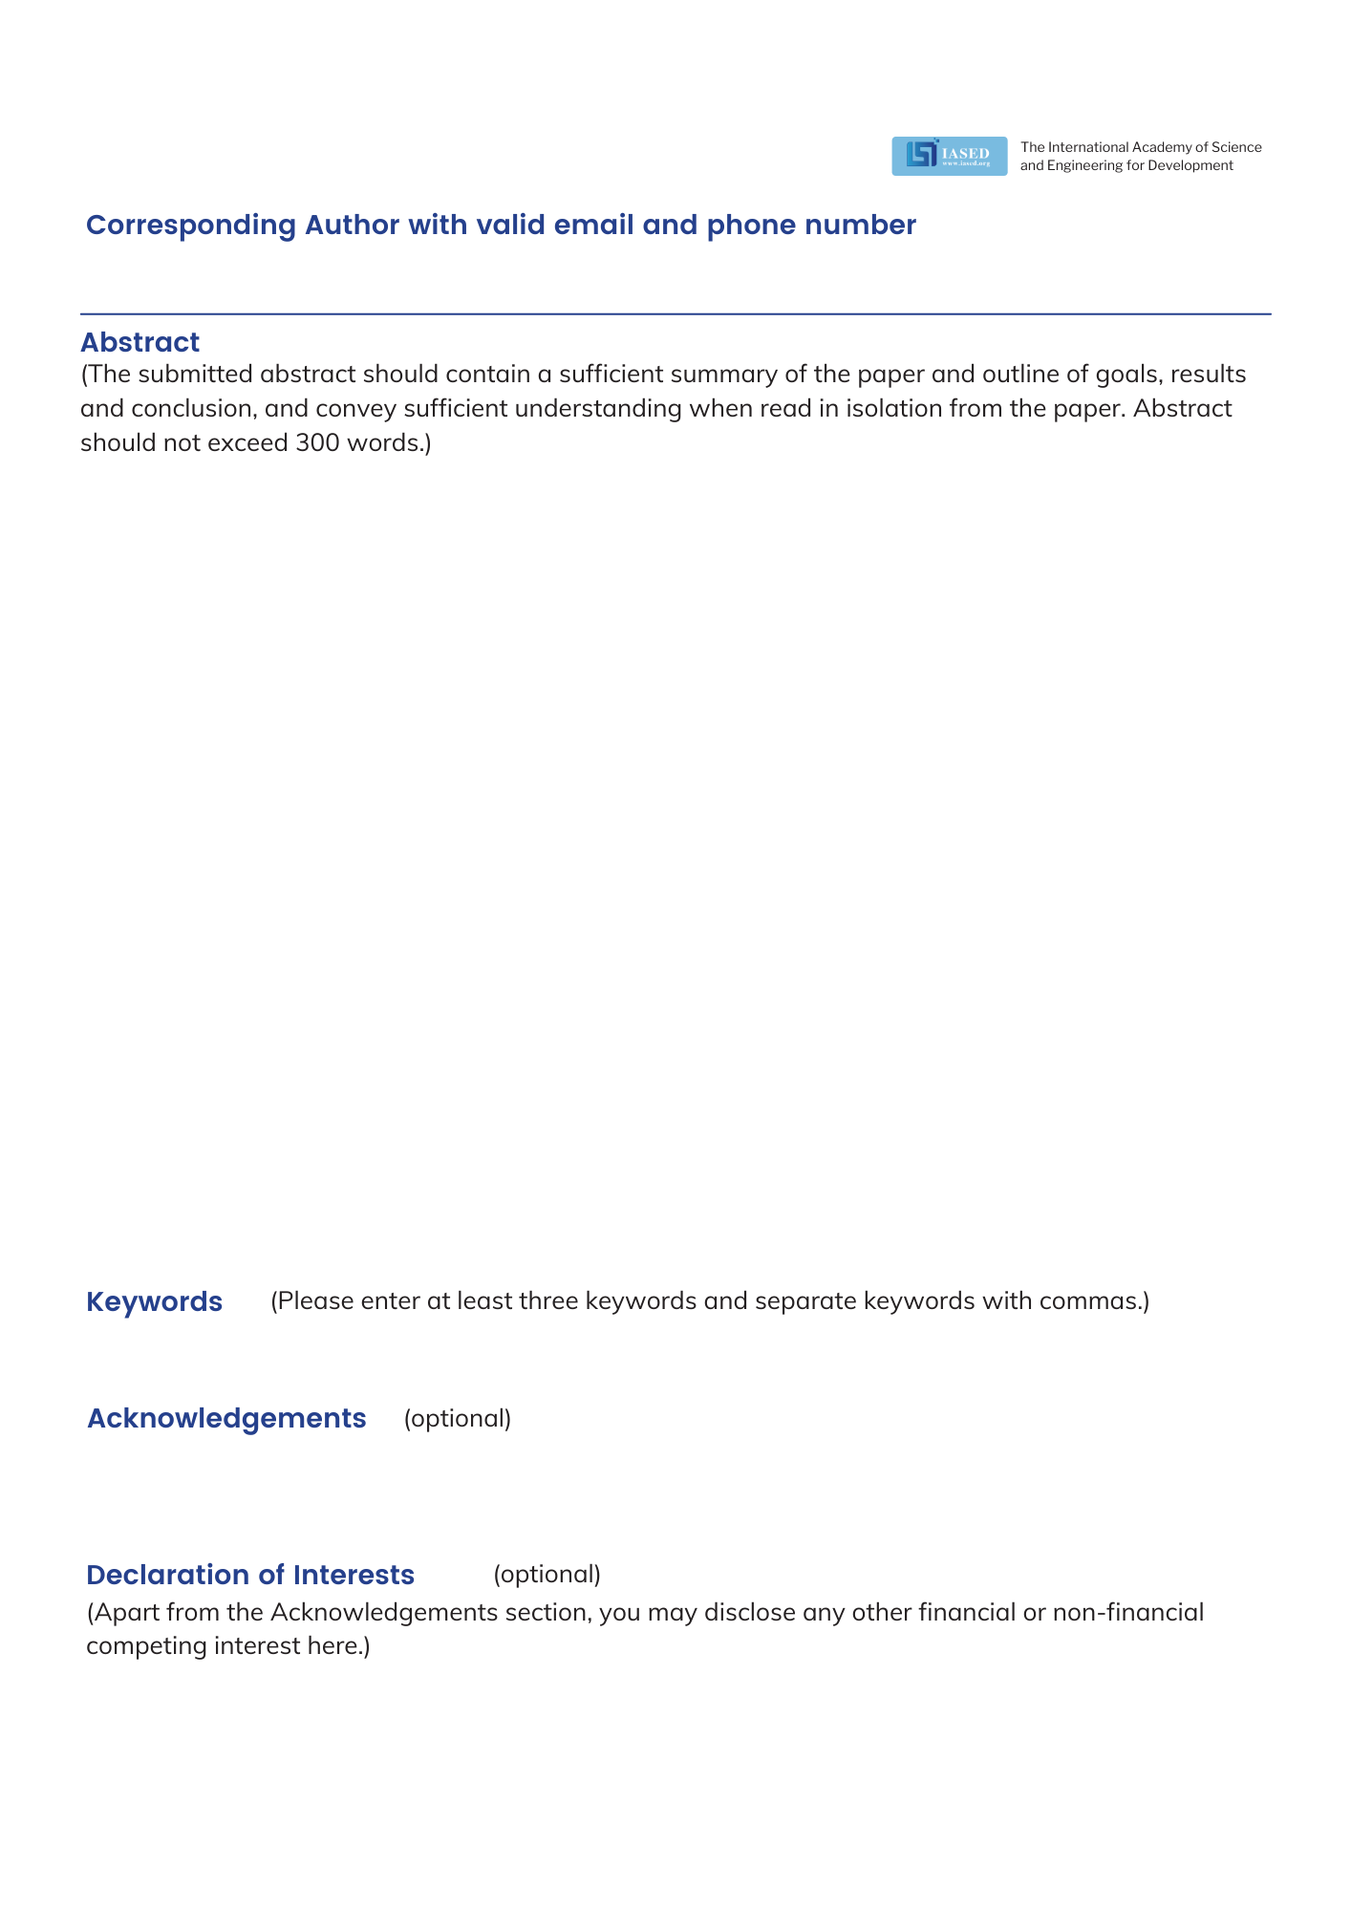

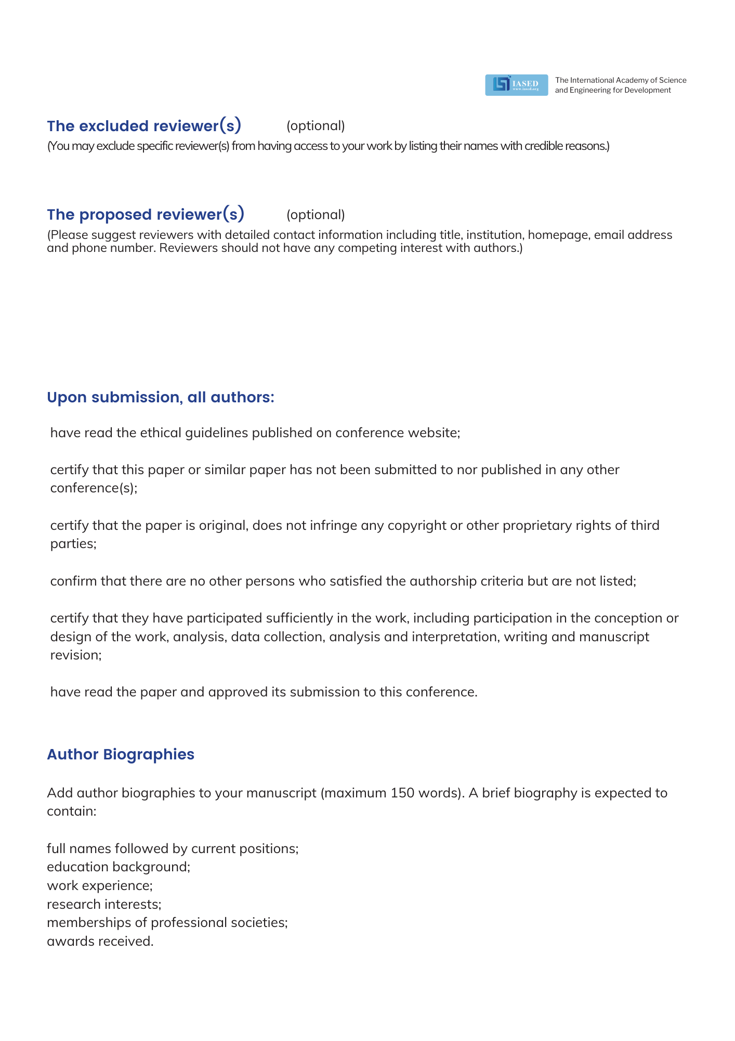



Conference Secretary: Katie Ouyang
Conference Email: contact@iccaee.net
Tel: 028-85586839 (Mainland);
+86-28-85586839 (International)
Monday-Friday, 9:30 am-12:00 pm and 1:30 pm-6:00 pm
Full Name | Short Biography (Maximum 150 words)

