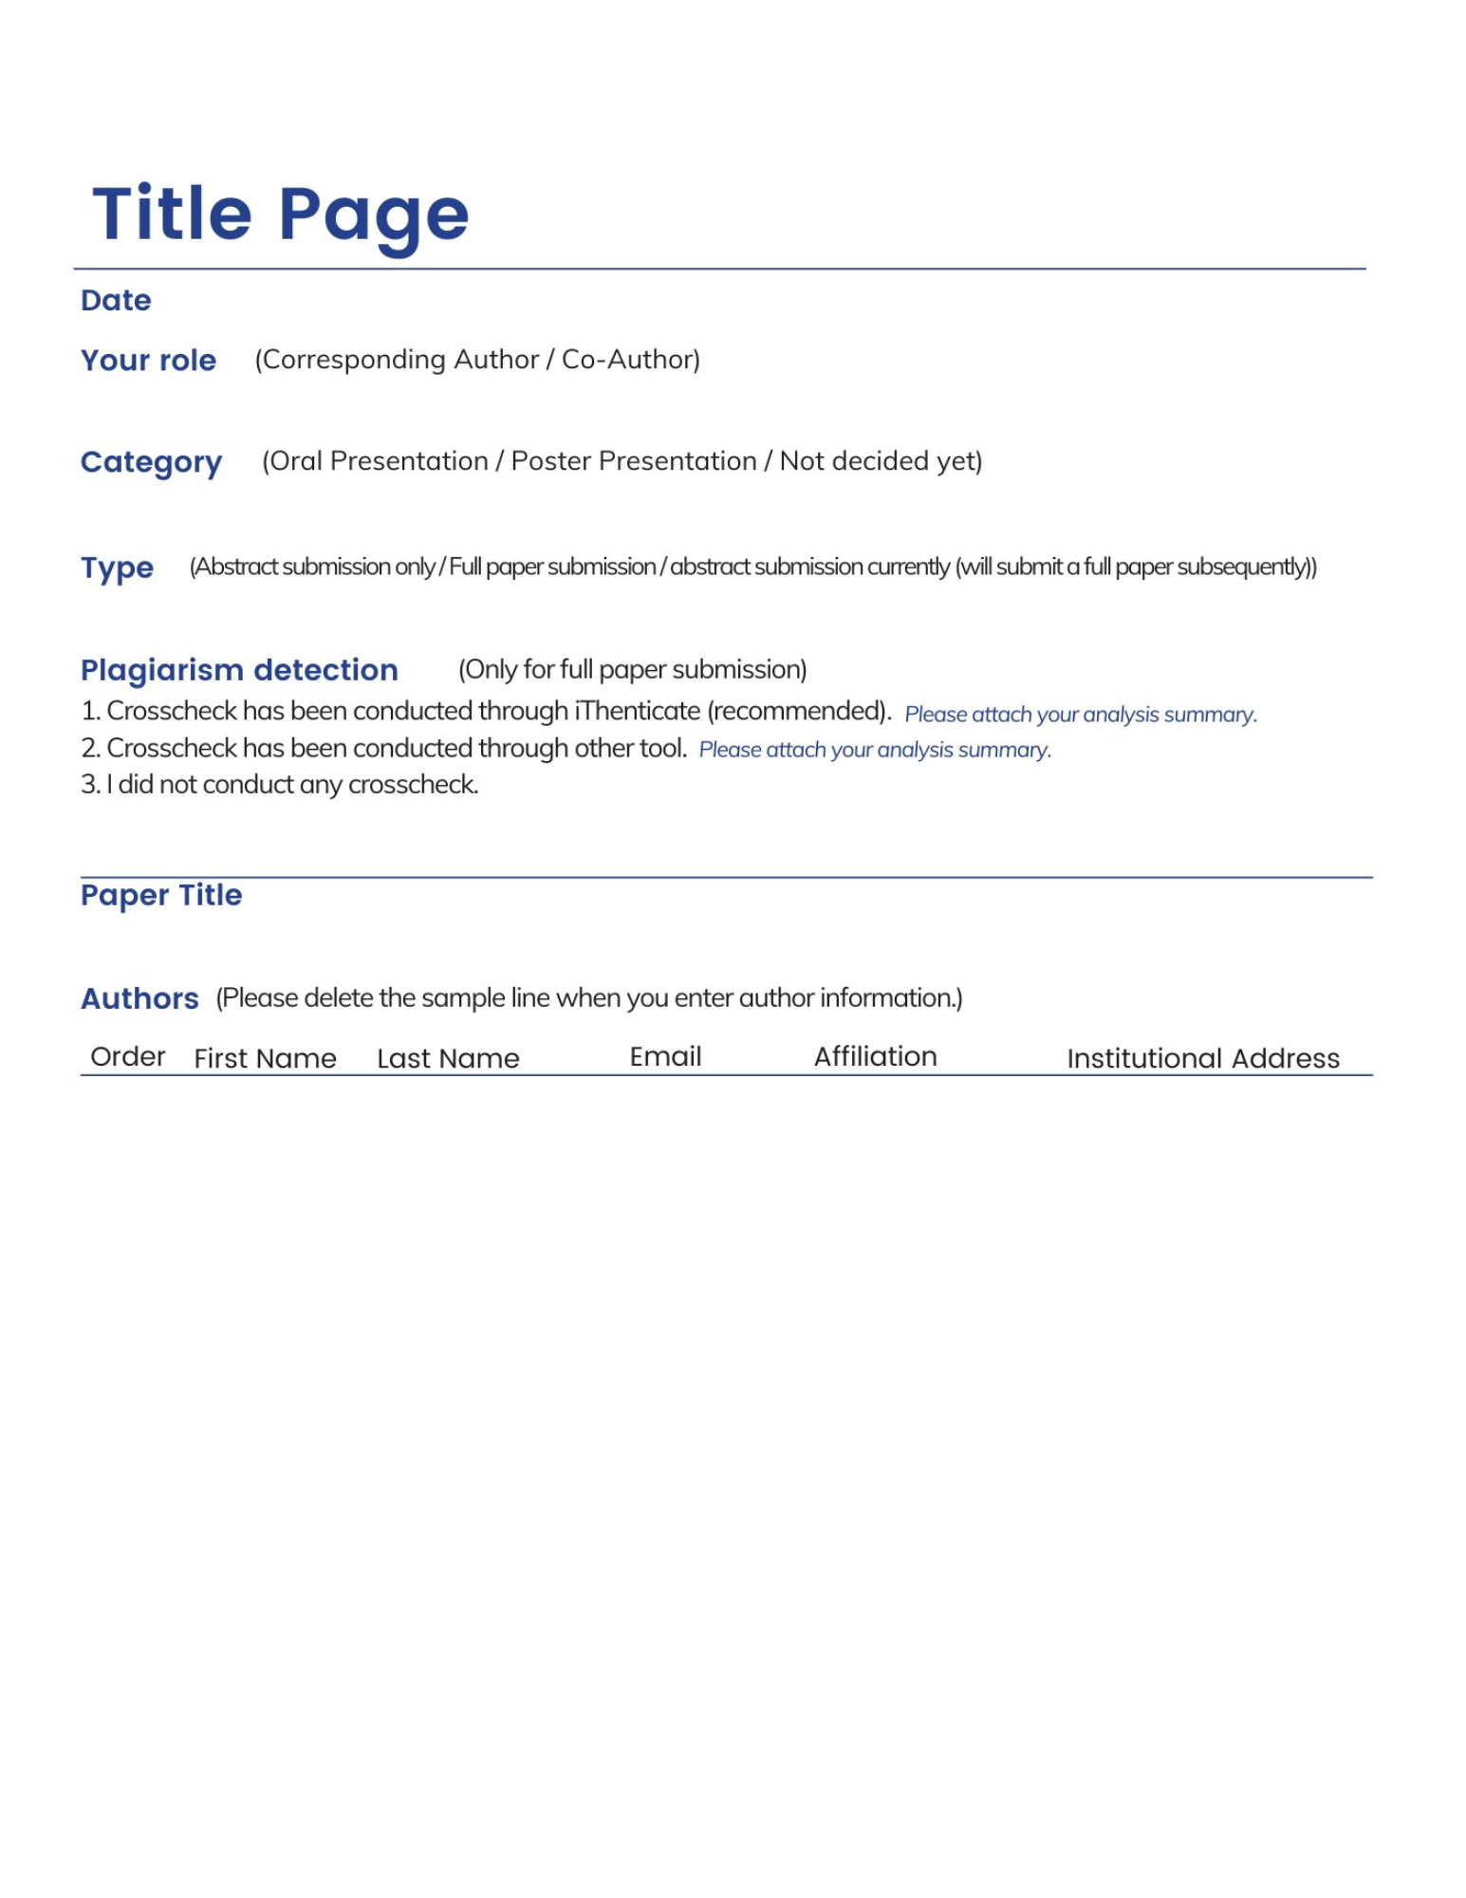

1
2
3
4
5

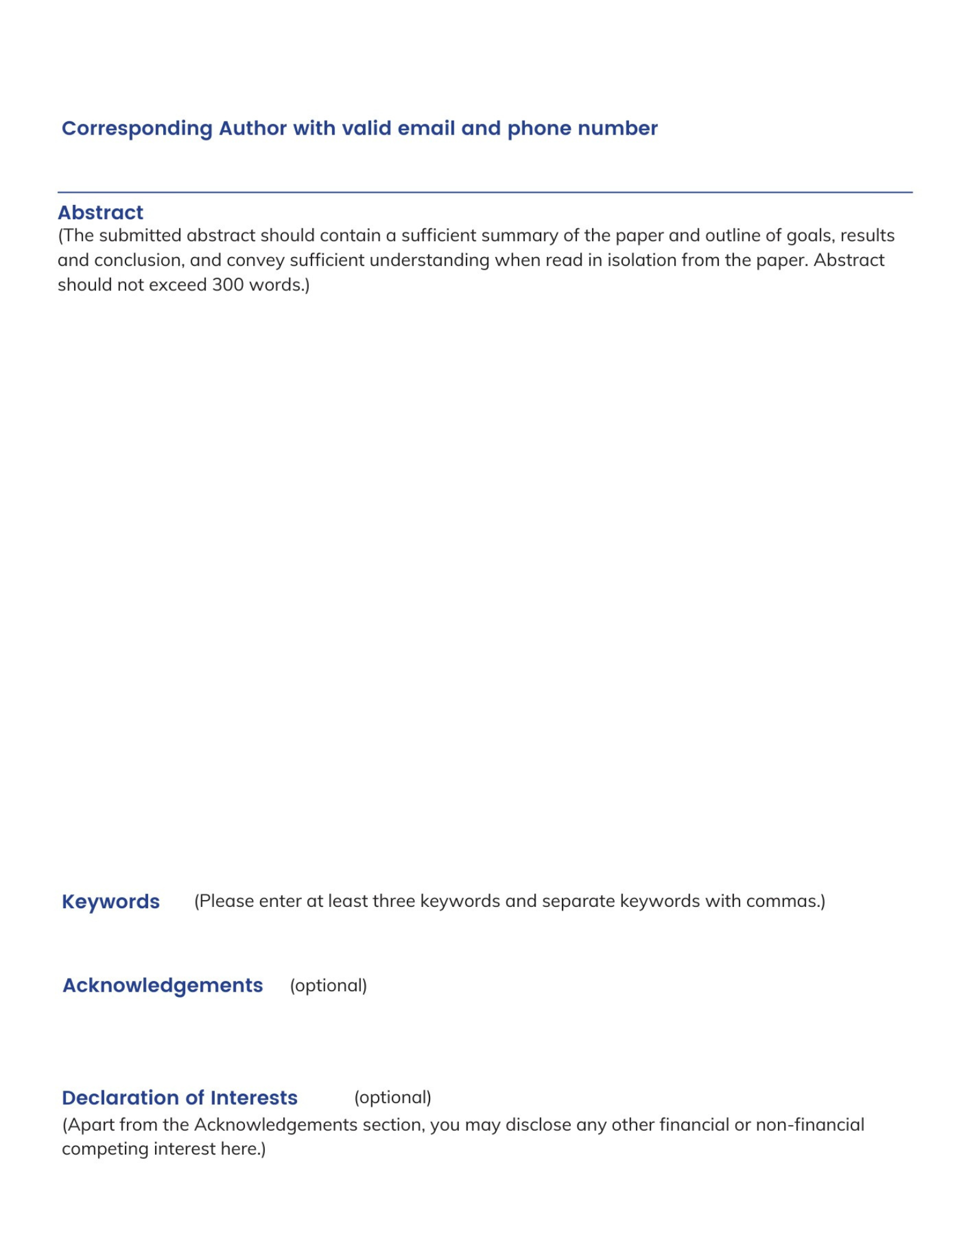

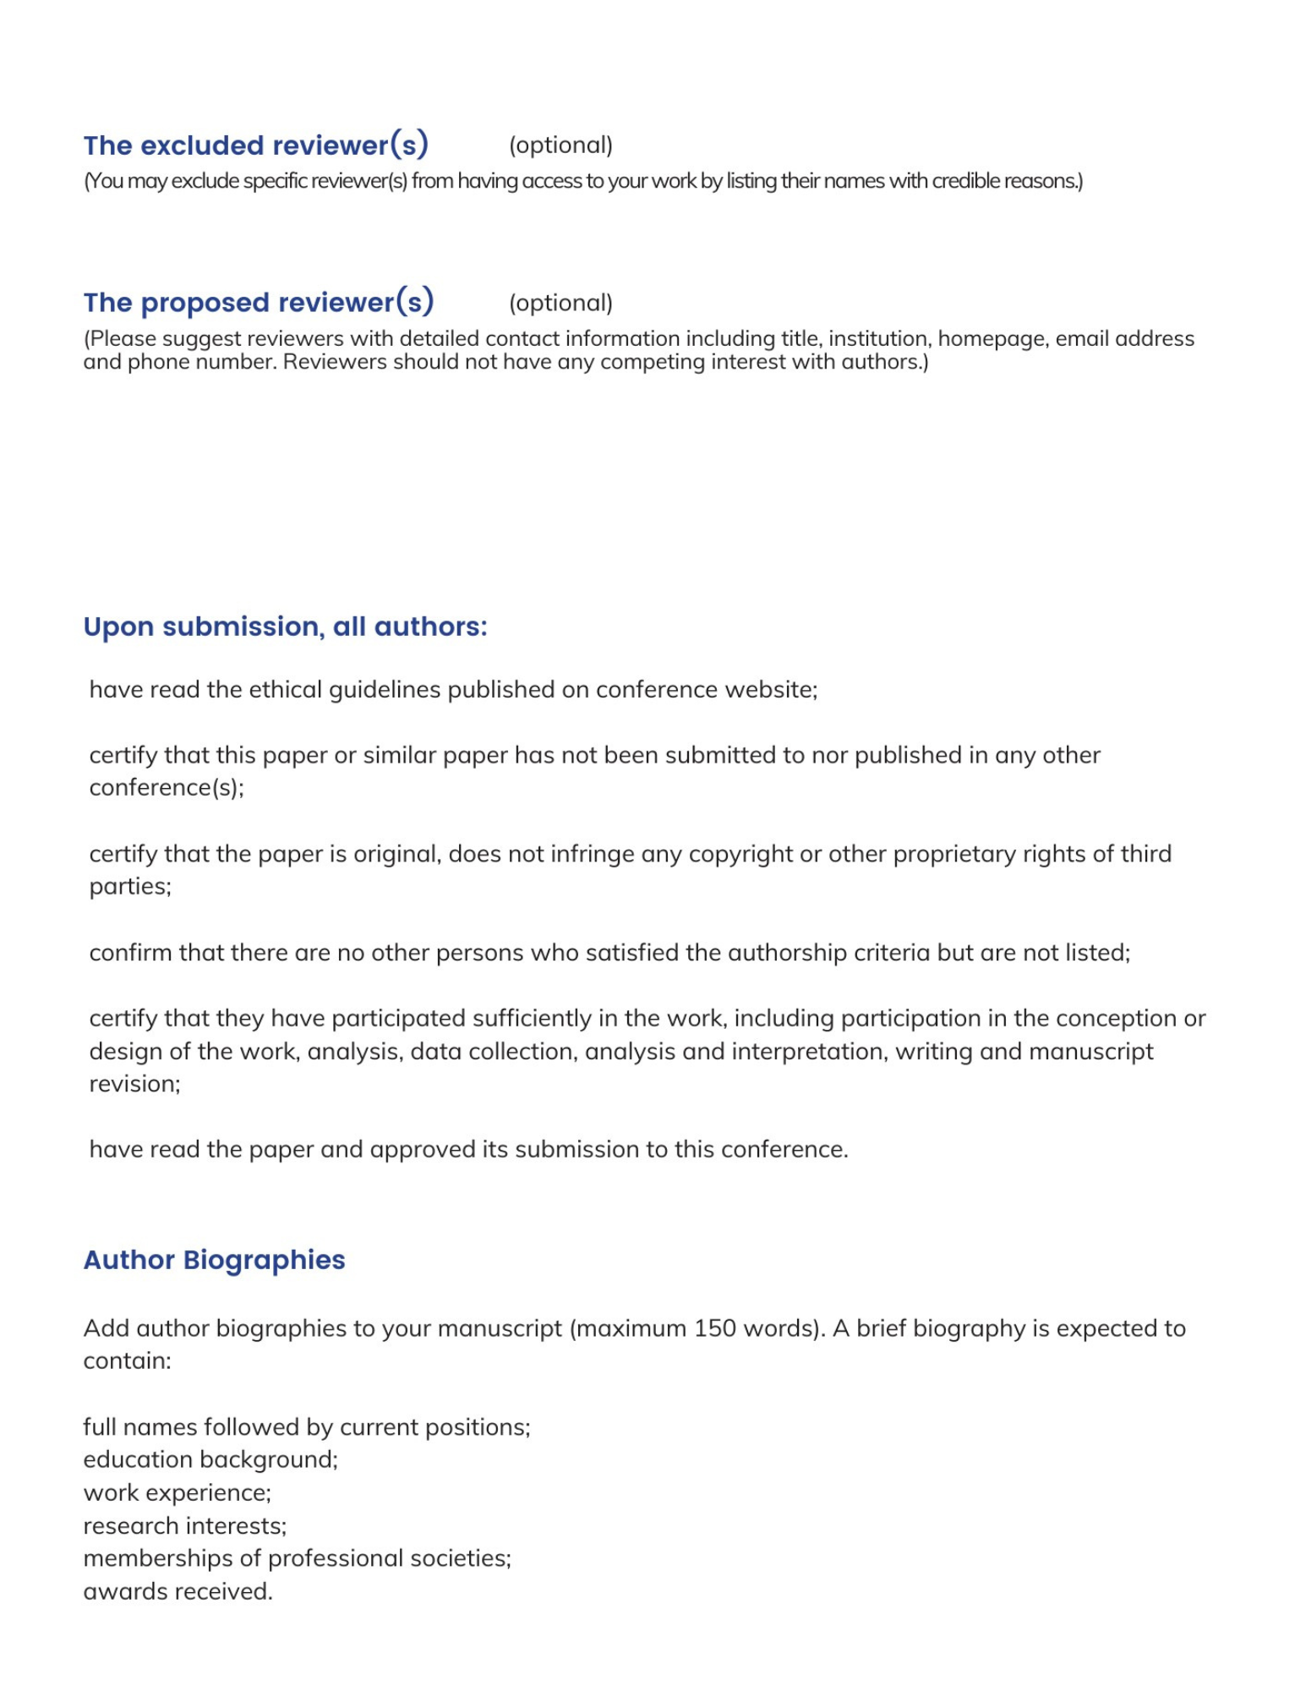

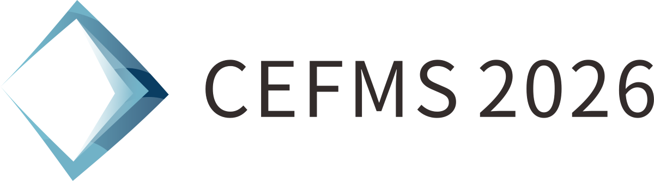

Dora Wu
Conference Email: inquiry@cefms.org
Tel: 028-85027305 (Mainland)
+86 28 85027305 (International)
Monday-Friday, 9:00am-12:00am and 13:30pm-18:00pm
Full Name | Short Biography (Maximum 150 words)

