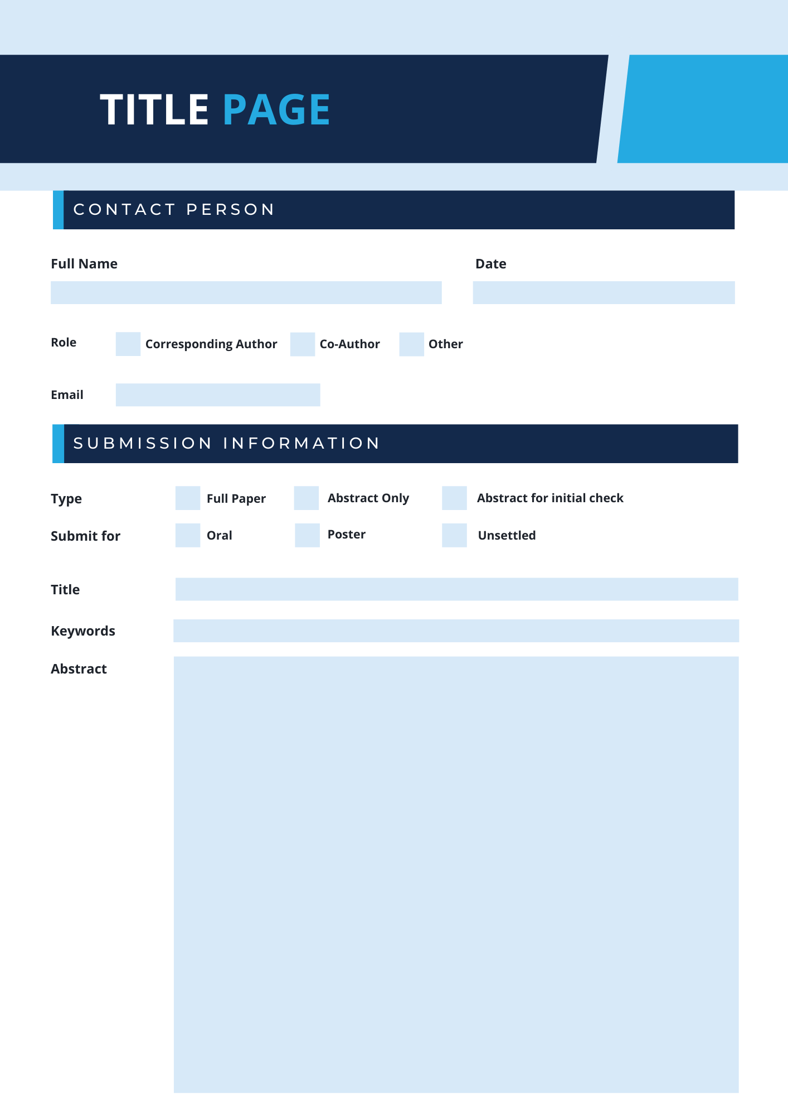

✔

✔
✔

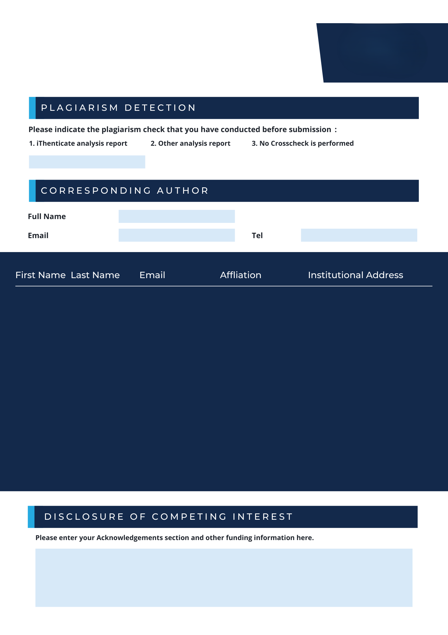

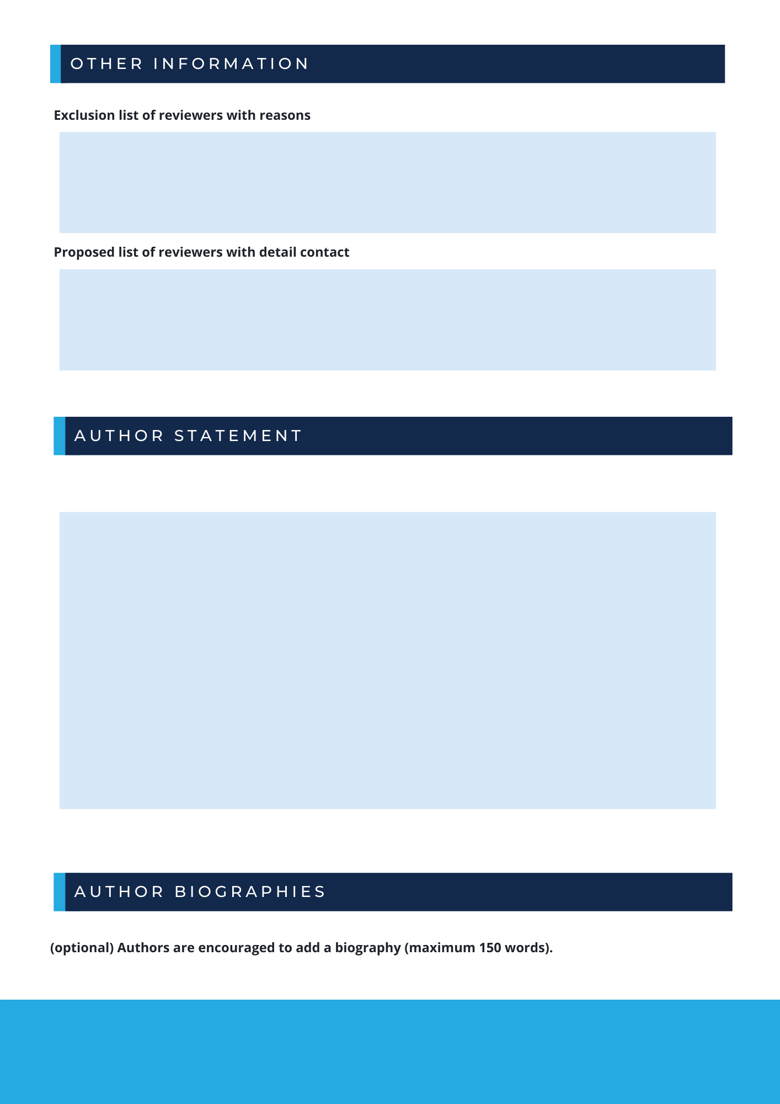

Upon submission, all authors should guarantee:
- the works included in the submission are original, without infringement of third-party rights;
- all authors have read the ethical guidelines on the conference website;
- there is no simultaneous submission, duplicate or redundant publication;
- all of those who have contributed significantly to the research (including the research conception or design, or acquisition of data, or the analysis, or interpretation of data and manuscript revision) have been listed as co-authors;
- all authors have checked and approved the submitted version of manuscript;
- all authors have approved the conference to which the manuscript is submitted.

Name | Brief Bio

Please feel free to contact us at inquiry@evpt.org for any questions regarding the manuscript submission.

